Ex 1: Folosind clauza with, pentru fiecare departament afisati informatii despre angajatii cu cel mai mare salariu din acel departament.

Daca intr-un departament nu lucreaza nimeni, veti afisa un mesaj corespunzator (diferit de "nu lucreaza nimeni").

with tabela as (

select *

from employees

where (salary, department_id) in (

select max(salary), department_id

from employees

group by department_id))

select department_id,

case when (select count(*) from employees e where e.department_id = d.department_id) = 0

then '0'

when (select count(*) from employees e where e.department_id = d.department_id) != 0

then (select t.last_name from tabela t where t.department_id = d.department_id)

end as last_name,

case when (select count(*) from employees e where e.department_id = d.department_id) = 0

then '0'

when (select count(*) from employees e where e.department_id = d.department_id) != 0

then (select t.first_name from tabela t where t.department_id = d.department_id)

end as first_name,

case when (select count(*) from employees e where e.department_id = d.department_id) = 0

then 0

when (select count(*) from employees e where e.department_id = d.department_id) != 0

then (select t.salary from tabela t where t.department_id = d.department_id)

end as salariu

from departments d;

--27 rezultate

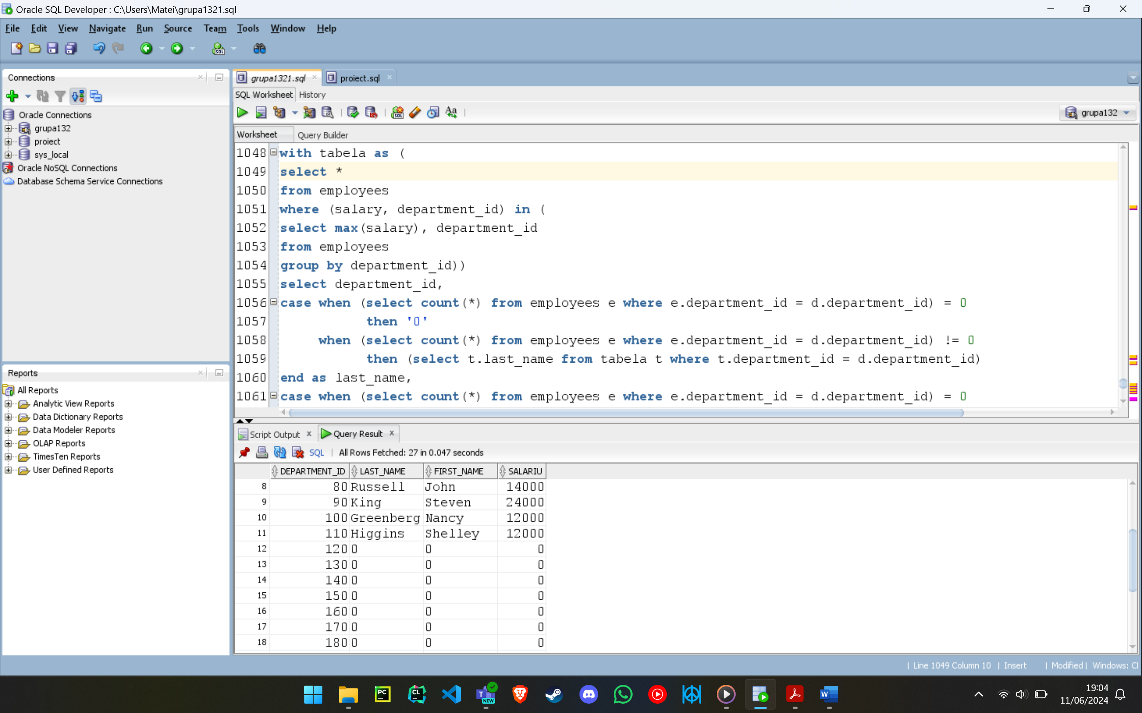

Ex 2: Afisati codul si numele departamentului si numele complet al managerului departamentelor pentru managerii de departament avand salariul mai mare decat media salariilor angajatilor al caror sef direct are un numar de telefon ce contine sirul "67".

select department_id, department_name, first_name || ' ' || last_name manager

from employees join departments using(department_id) where employee_id in (

select distinct manager_id from employees where manager_id in (

select employee_id from employees where salary > (

select avg(salary) from employees where employee_id in (

select employee_id from employees where manager_id in (

select employee_id from employees where phone_number like '%67%')))));

--12 rezultate

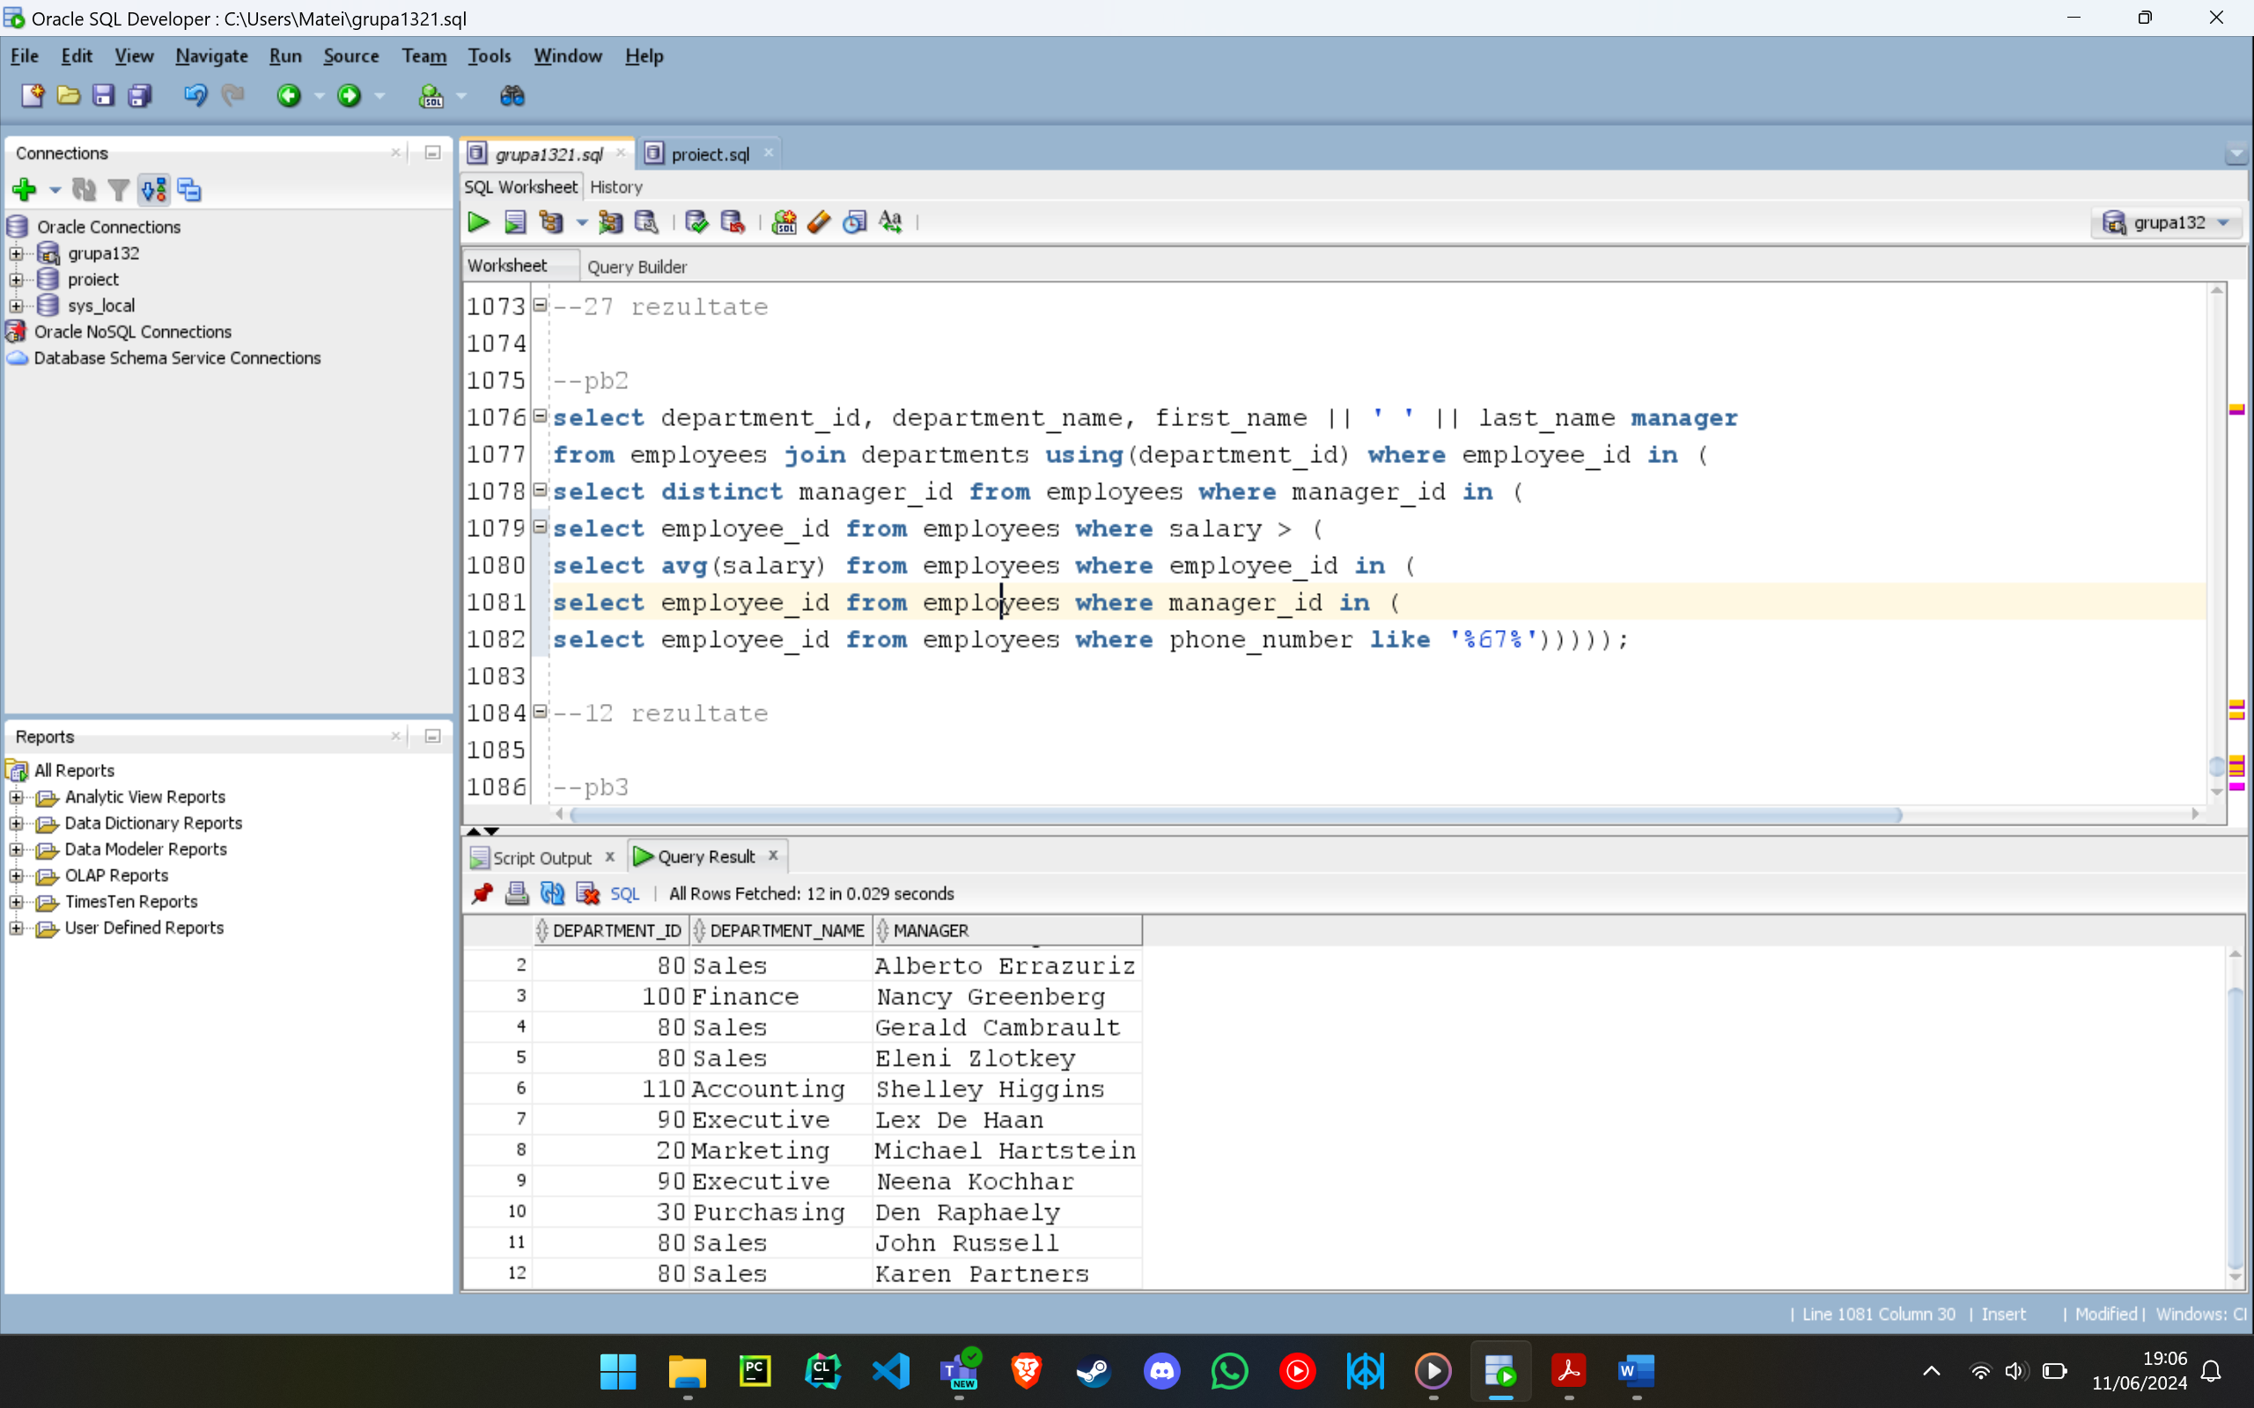

Ex 3: Afisati departamentele in care lucreza angajati al caror manager direct are un numar de telefon ce contine fix 10 CIFRE. (Atentie la forma actuala a numerelor de telefon din baza de date. Folositi doar functiile prezente in fisierele oferite ca suport la laborator.) Se vor afisa doar departamentele a caror medie salariala este mai mare decat media salariala a intregii firme.

select distinct department_id

from employees

where manager_id in (

select employee_id from employees where phone_number like '___.___.____')

and department_id in (

select department_id from employees group by department_id having round(avg(salary)) > (

select round(avg(salary)) from employees));

--7 rezultate

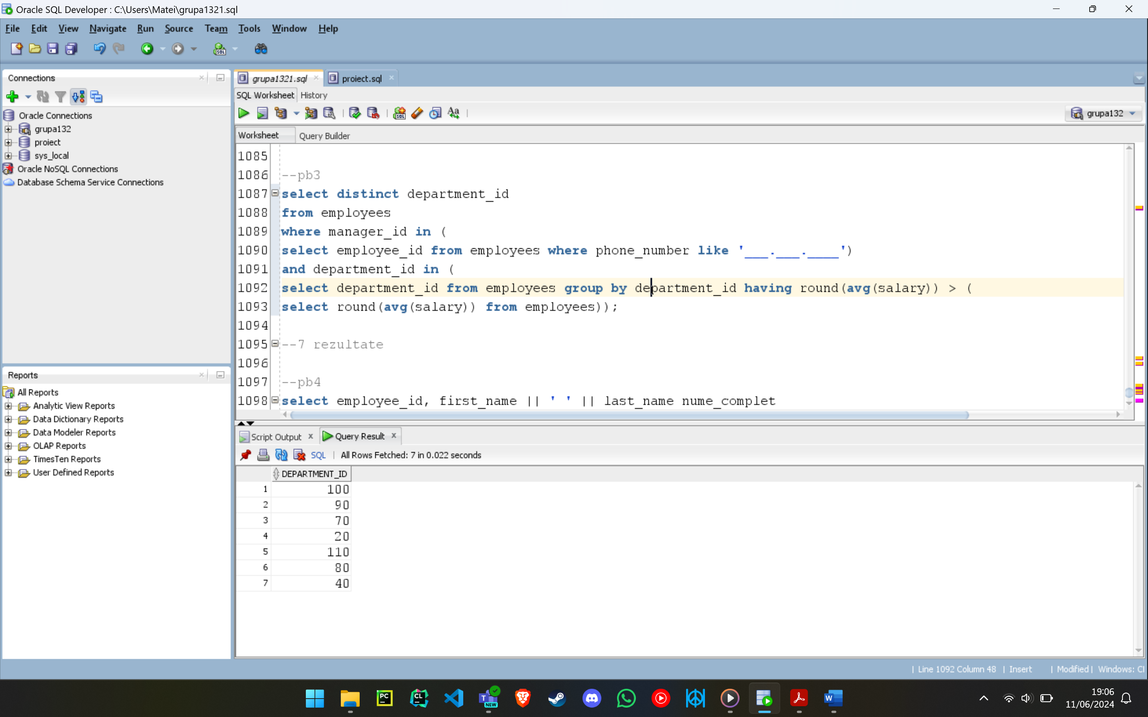

Ex 4: Sa se listeze angajatii (codul si numele acestora) care au lucrat pe toate proiectele nelivrate la termen.

select employee_id, first_name || ' ' || last_name nume_complet

from employees

where employee_id in (

select distinct employee_id

from works_on a

where not exists (

select 1 from project p where delivery_date > deadline and not exists (

select 'x' from works_on b where a.employee_id = b.employee_id and b.project_id = p.project_id)));

--2 rezultate

